1.堆栈的数组实现:
/*堆栈的数组实现*/
#include<iostream.h>
#define MAXSIZE 5
int top=-1;//定义栈顶指针
int Stack[MAXSIZE];//定义堆栈数组
int IsEmpty()//判空
{
if(top==-1)
return 1;
else
return 0;
}
int IsFull()//判满
{
if(top==MAXSIZE-1)
return 1;
else
return 0;
}
void Push(int i)//入栈
{
if(IsFull())
{
cout<<"栈满，无法入栈。"<<endl;
return;
}
else
Stack[++top]=i;
}
int Pop()//出栈
{
if(IsEmpty())
{
cout<<"栈空，无法出栈。"<<endl;
return -1;
}
else
return Stack[top--];
}
void main()
{
Push(1);
Push(2);
Push(3);
Push(4);
Push(5);
Push(6);
Push(7);
cout<<Pop()<<endl;
cout<<Pop()<<endl;
cout<<Pop()<<endl;
cout<<Pop()<<endl;
cout<<Pop()<<endl;
}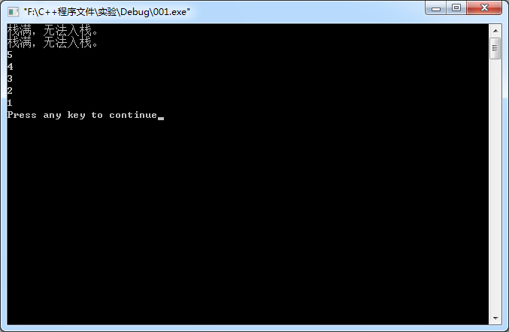
2.堆栈的链表实现:
/*堆栈的链表实现*/
#include<iostream.h>
struct Node
{
int num;
struct Node *next;
};
Node *top=NULL;//栈顶指针
int IsEmpty()//判空
{
if(top==NULL)
return 1;
else
return 0;
}
void Push(int num)//入栈
{
Node *newnode=new Node;
newnode->num=num;
if(top==NULL)
{
top=newnode;
newnode->next=NULL;
}
else
{
newnode->next=top;
top=newnode;
}
}
int Pop()//出栈
{
int k;
Node *ptr;
if(IsEmpty())
{
cout<<"栈空，无法出栈。"<<endl;
return -1;
}
else
{
ptr=top;
k=top->num;
top=top->next;
delete ptr;
return k;
}
}
void main()
{
for(int i=1;i<=5;i++)
Push(i);
cout<<Pop()<<endl;
cout<<Pop()<<endl;
cout<<Pop()<<endl;
cout<<Pop()<<endl;
cout<<Pop()<<endl;
cout<<Pop()<<endl;
}
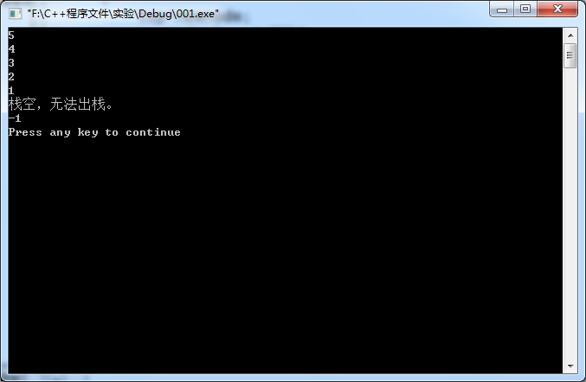

#include<iostream>
using namespace std;
class node
{
public:
int num;
node *next;

};
node *top = NULL;
int IsEmpty()
{
if (top == NULL)
return 1;
else
return 0;

}
void push1(int x)
{

node *ptr = new node;
ptr->num = x;

ptr->next = top;
top = ptr;

}
int pop1()
{
if (IsEmpty())
{
cout << "栈空，无法出栈" << endl;
return -1;
}
node *ptr = top;
top = ptr->next;
int temp = ptr->num;
delete ptr;
return temp;
}
void print()
{
node *p=top;
while (p!= NULL)
{
cout << p->num << " ";
p = p->next;
}
cout << endl;
}

void main()
{
for (int i = 0; i < 5; i++)
{
push1(i);
print();
}
push1(7);
print();
system("pause");

}

